Library Newsletter

Oakhurst Baptist Church, Decatur, GA www.oakhurstbaptist.org Issue #7, Fall 2010

Conservative Magazine Becomes Progressive
By Harold Hoffman
About fifty years ago I started reading Christianity Today (available in our library). At that time it was founded by Billy Graham and others as a counter-weight to raw fundamentalist theology and it remained neo-conservative. The first editor, Carl F. H. Henry was a trained journalist and theologian. He once rose at a press conference with Carl Barth and identified himself as editor of Christianity Today. Barth is reported to have replied, “Don’t you mean Christianity Yesterday?,” which got a great laugh from the large audience. Forty years later it has become the non-denominational magazine with the largest circulation in America. Today the magazine has an expanded religious news section, takes on controversial issues, tries to defend biblically based faith and has extensive spring and fall book reviews. Check out the September issue which features Jesus in sun glasses on the cover and the statement, “What happens when ‘cool’ meets Christ”? See articles on sex offenders in church, an extensive article on welcoming the offenders in our midst. A piece on Ayn Rand’s Alternative Religion (Libertarianism) and one which asks “Are Christian
Hipsters Anti-Evangelical?”
Magazines may be checked out for two weeks.☻

Stewardship

A Christian steward wants to get value for all his or her purchases. It’s not only good for the world’s rapidly depleting resources, but it’s the right thing to do for today’s economic situation. We need to wean ourselves from the “throw away society” and listen again to old Ben Franklin who said “waste not, want not.” Our library subscribes to Consumer Reports magazine. Notice the November issue titled “Best Buys of the Year” with reports on 400+ great buys. ☻

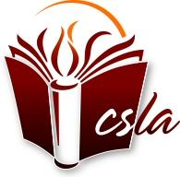Member of Church & Synagogue Library Association

LIBRARY AUTOMATION
Work in Progress by Rachael Beascoechea
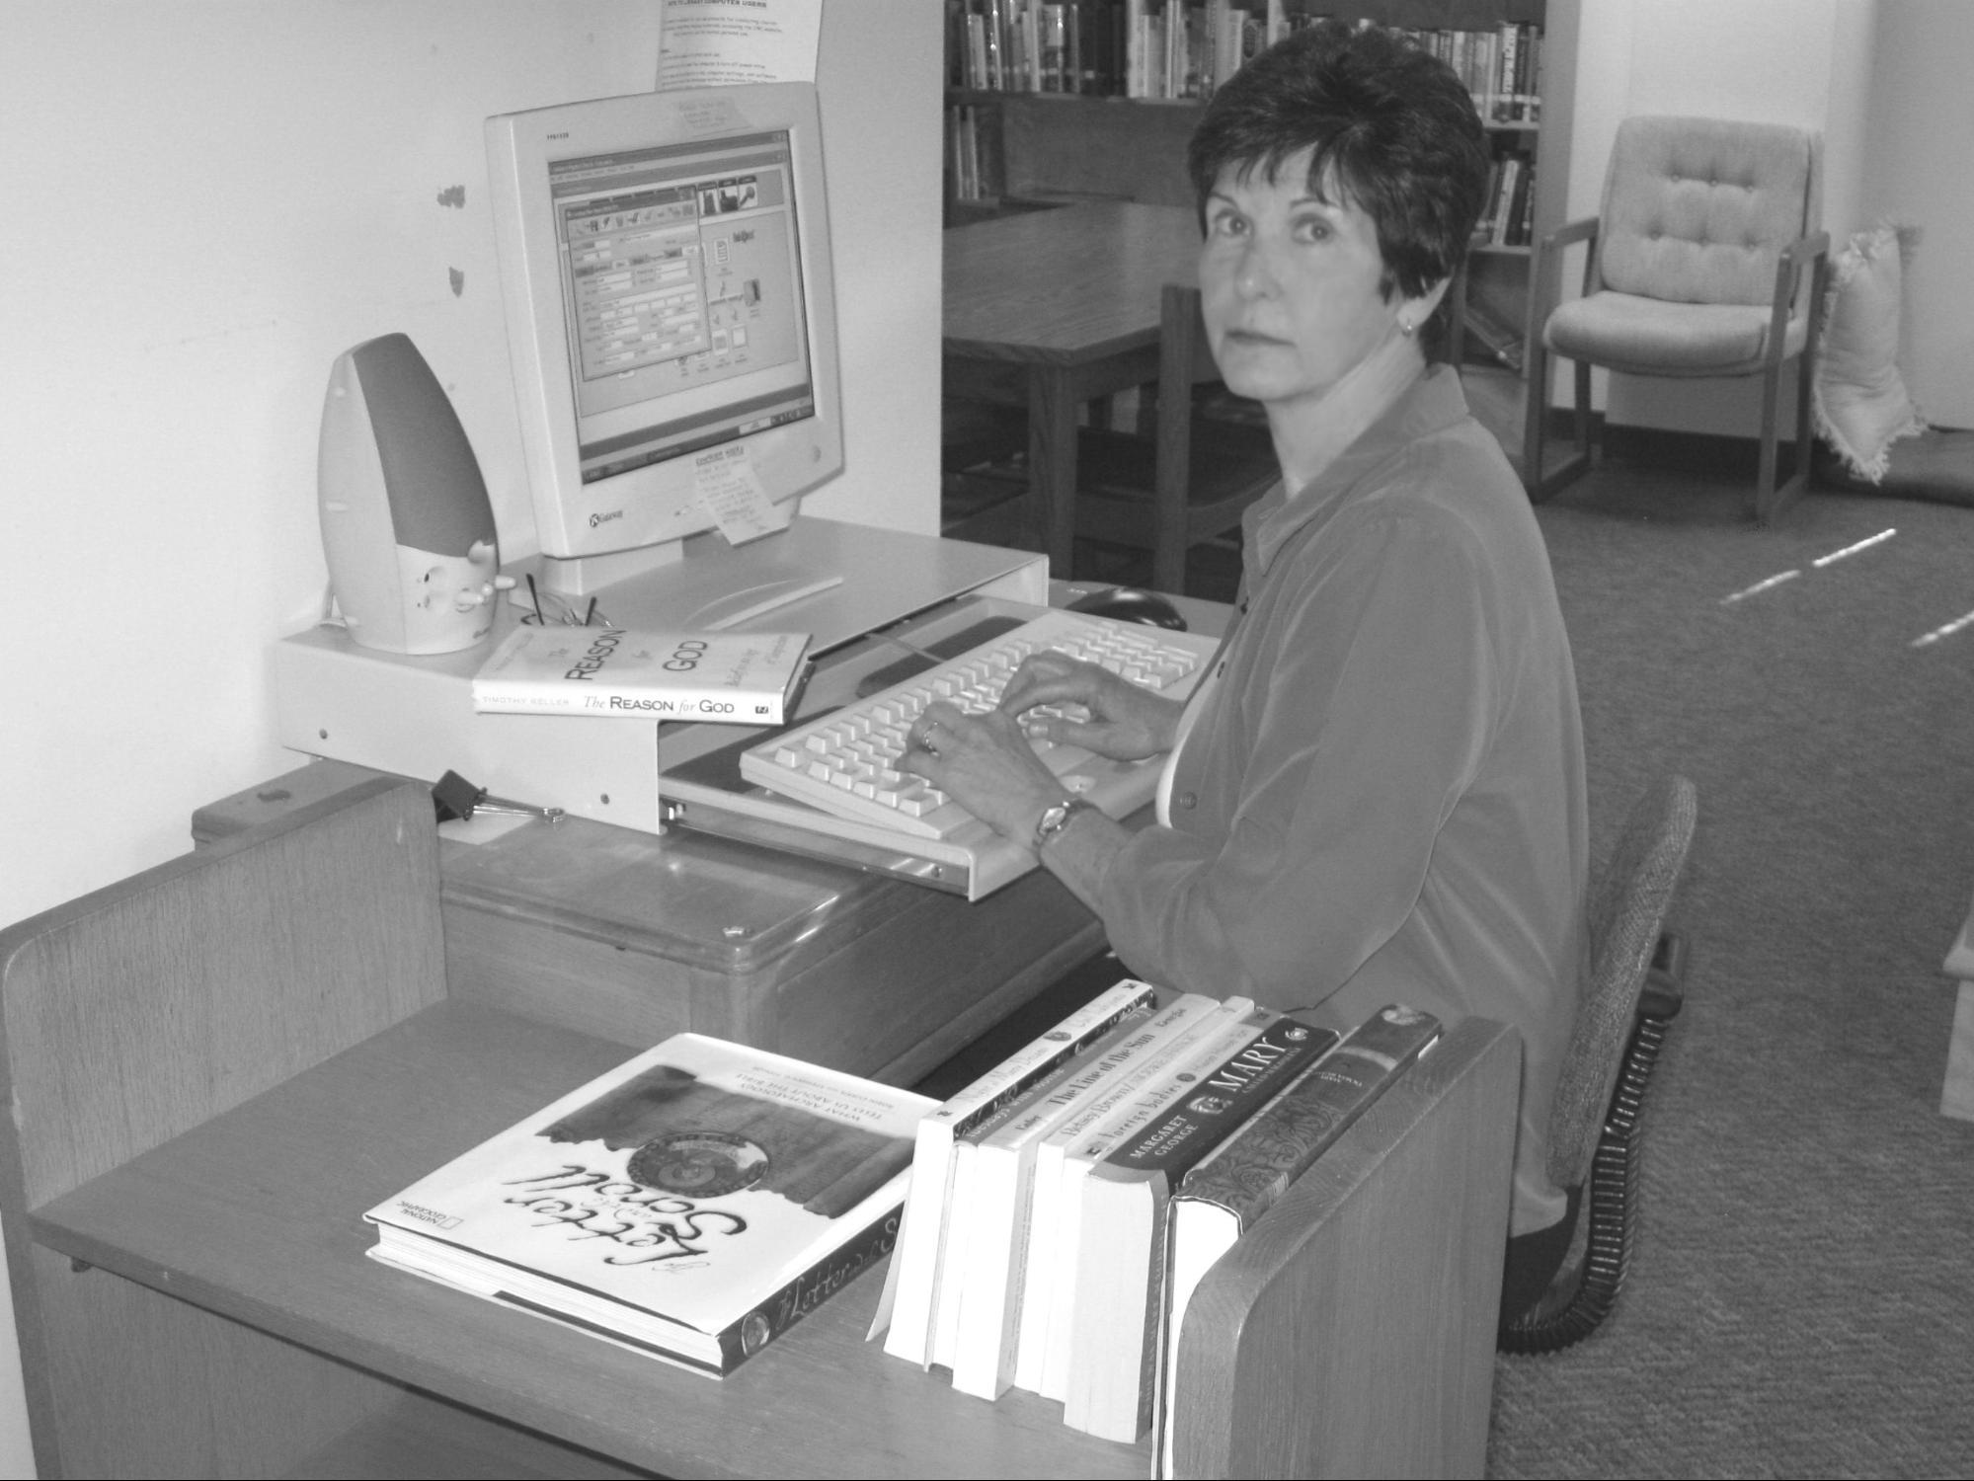
Since becoming a member of the library committee about 4 years ago I’ve found processing books in and out of our collection to be the most challenging task in keeping the library organized and up to date. Using the old card catalog system is an extremely time consuming way of processing books. It may work fine for very small libraries or libraries with a paid staff or lots of volunteers, but it does not work well at Oakhurst where the library is managed by a small six person volunteer committee. After much discussion by committee members and after approval of an increased 2010 budget along with the use of some of the library’s restricted fund, we purchased MLS/Concourse library automation software in April 2010. Concourse was designed and developed for church libraries by Book Systems, Inc. Concourse is simple to use and will allow library committee members to process books in and out of the library collection much more easily and will also improve the organization and usability of the library. The most daunting task upfront is to enter all the books in our collection into the Concourse System. To date, we have 2,252 books entered on the computer. All children’s, juvenile, adult fiction, and approximately 468 books beginning in the call number 200 series have been entered so far. Also, all the new books added to our collection since April have been entered.

Recently, Oakhurst member Frank Painter volunteered to help with data entry, beginning with biographies. Once our entire collection has been entered into Concourse, I will offer training to interested members on how to search for books using the automated system. In addition, a hard copy printout of all books will be available in the library.
New Additions
Among the many new additions to our library collection is an unusual book by a local storyteller-humorist and NPR contributor--The Cracker Queen: A Memoir of a Jagged, Joyful Life by Lauretta Hannon. The book is described as “a poignant memoir of life on the wrong side of the tracks, with a colorful cast of misfits, plenty of belly laughs, and lessons for finding joy in spite of hardship.” Here is an excerpt from the first chapter of the book:
“Give me your broken and broke-down. Your worn-thin and your whacked-out. The undesirables, the uneducated, and the hopelessly out-of-date. For in them the human spirit reveals its strength and beauty…I have been among them my whole life. I am them.”
Library Mission
The committee recently completed a policy and procedure manual which is available for review on the library desk and on our webpage. In it we state our mission is to provide a collection of materials for members and friends which will
- Serve those who seek to grow in their understanding of the Christian faith
- Serve those seeking to develop a deeper understanding of one’s self and one’s role in the community and the world
- Provide for the support of the church’s programs and covenant
Circulation Policy - Updated
The Library is open whenever the building is open. Self service check out procedures are posted on the library desk and someone is usually there to help you shortly before and after worship service. Please be sure to clearly stamp or write the book’s DUE DATE (2 weeks after checkout) on BOTH the card and the card pocket in the back of the book. Write your name and email address or phone number on the card and leave it on the desk. Materials may be renewed upon request. There are no overdue fines, but effective today, we will request compensation for or replacement of materials that are lost or not returned within six months. This new policy is posted in the library. We also have copies of worship service DVD’s available for check out.

Rachael Beascoechea
Photo by Jan Murphy

Continued on Page 2

MY TREASURED BOOKS
by Geoff Sumner
Books that influenced my life:

1. Soul's Code by James Hillman. Best psychology book ever. Actually helpful.

2. The Blessing is Next to the Wound by Hector Aristizabal. Transformational.

3. Runelore by Edred Thorsson. An amazing look at traditional Western esotericism.

4. The King and the Corpse by Heinrich Zimmer. Great myth.

5. Confessions of a Radical Traditionalist by John Mitchell. Food for thought.

A book to which I always return:
The Poetic Edda - Lee Hollander translation. The actual gods and heroes of our ancestors.

Classic that I really tried to read but could never finish:
Ulysses

Book that I am reading right now:
Frankenstein by Mary Shelley.

Book that I recommend for your children:
Dr. Seuss, Grimm, traditional poetry/nursery rhymes.

Look for more “TREASURED BOOK” series from other Oakhurst members in future newsletters.

Your Library Committee (we’re here to help):
Harold Hoffman, co-chair - Halbea2000@bellsouth.net
Jan Murphy, co-chair – jamnga@bellsouth.net
Rachael Beascoechea – robeas138@bellsouth.net
Carolyn Copenhaver - CdenC@aol.com
Al Crisp - ACCrisp@aol.com
Lou Clymore – leonluella@bellsouth.net
Angela Riccetti - AJRICCETTI@Comcast.net

