Library Newsletter

Oakhurst Baptist Church, Decatur, GA www.oakhurstbaptist.org Issue #9, Fall 2011

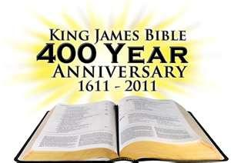
By Harold Hoffman
Our library is sponsoring this significant anniversary in the following way: before October 26 a display of placards will line the lower bridge between the choir room and the fellowship hall. Reproductions of pages from eight English Bibles that preceded the KJV may be viewed; copies of the first edition of the KJV are included. Just outside the Fellowship Hall can be seen numerous books and magazines from our library that can be checked out. In the second floor library there will be some KJV Bibles loaned by members along with a brief story as to why the books are so treasured.
Wednesday, October 26 at 6:30 p.m., the first part of the movie entitled, Battle for the Bible will be shown followed by discussion. The second half of the film will be shown on Wednesday, November 9 at
6:30 p.m. Sunday, Oct. 30 is Reformation Sunday and we will remember those who risked their lives to bring us this version of the Bible which has been one of the English speaking church’s most enduring treasures. All of this history is important to Oakhurst since the Bible from which we read each Sunday – the New Revised Standard Bible -- is a direct descendent of the four hundred year old best seller – the KJV.
COME LEARN; BE INSPIRED.
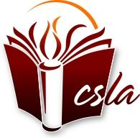Member of Church & Synagogue Library Association

Jennie Knight Book Signing
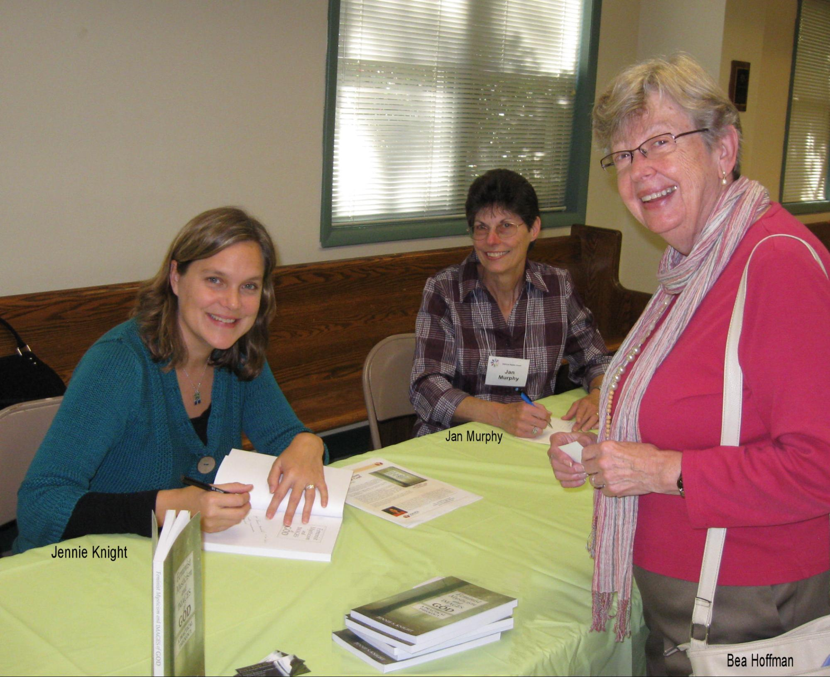
The Library Committee and the Divine Feminine Class co-sponsored a book signing by Jennie Knight on Sunday, October 16th. The event was well attended by about 20 people, while Jennie autographed her book and chatted with members. We are so proud of Oakhurst member, Rev. Dr. Jennie S. Knight, for her recent publication of Feminist Mysticism and Images of God: A Practical Theology (Chalice Press, May 2011). Jennie has also published several journal articles and book chapters about Transformative Religious Education with Youth, Intergenerational, Cross-Cultural Community-Based Religious Education, and Religion and Popular Culture. She loves to teach and lead workshops for laypeople and clergy alike. Check out Jennie’s website and blog at http://jenniesknight.com/. ☺
Calling all Youth…
The Library Committee is coming to the Youth Sunday School Classes in November/December to stir up the excitement for reading and using the Library resources we have! Please talk with your children and teens about what books and other materials they would want to see in the Library that would inspire them to take advantage of this great Oakhurst resource. Please forward your list of suggested acquisitions to John Starbuck at kcubratsej@aol.com or 404-783-4112 cell or 404-298-3286 home. Thanks! ☺

Automation Completed !
by Rachael Beascoechea
The process of inputting library books into the Concourse system was completed in September. Now that all the books are on Concourse it should be simple to process books in and out of our collection. It is also now possible to print out various lists about our collection including statistical information. For instance, we now have a report showing the approximate cost of the library’s collection of books by category and class. This is information the church can use for insurance purposes.
To replace the old card catalog system there are now two white binders containing listings on all books. These binders are located on top of the cabinet where the old library cards are stored. One binder is labeled Adult Books and the other is labeled Children and Juvenile Books. The Adult Book binder contains listings by Title, Author and Subject. The Children and Juvenile Book binder has books listed by Title and Author. Each of the binders also contains a section called New Additions. This is where we will put a printout of new books as they are added to the library. Once or twice a year as needed the binders will be updated with completely new lists.
Searching for books using the computer is also an option. As of now the Concourse software is only loaded on the computer in the library work room. Once the software has been loaded on the computer located in the main library, instructions on using Concourse to search for a book will be put next to the computer. In addition to the printed instructions, individual training on Concourse will also be made available to anyone interested. Details about the training will be provided once the software is installed on the main library computer. ☺

Thanks to Rachael, with help from Frank Painter, for the many tedious hours it took to input almost 4,000 books on the computer over the past 15 months.
We are happy to welcome John Starbuck to our library team. He brings lots of ideas and gifts to help breathe new life into our juvenile book collection and whatever else he’s led to do.
Co-Chair Jan Murphy

MY TREASURED BOOKS
by Mark Reeve
Books that influenced my life:
- Silent Spring, by Rachel Carlson (1962). Published while I was still in High School, it opened my eyes to environmental issues. It resulted in the 1972 ban on DDT in the USA.
- The Ugly American, by William Lederer and Eugene Burdick (1958). A novelization of the then-impending American quagmire in Viet Nam. It opened my eyes to the fact that Americans were not (and certainly today, are not) universally loved as liberators around the world.
- Original Blessing, by Matthew Fox (1983). The author lifts up a creation-centered tradition that he says predates traditional Christian concepts of “original sin” and the “fall/redemption ideologies” of organized Western religion.
- The Gospel in Solentiname, compiled by Ernesto Cardinal (circa 1976). In the 70’s, peasants in a remote archipelago in Lake Nicaragua gathered each Sunday to reflect on the gospel reading from the perspective of the oppressed. Liberation theologian Father Cardinal recorded their insights.
- The Left Hand of Darkness, by Ursula Leguin (1976). On the planet Winter, each individual has the potential to fulfill the male or female function in reproduction. This book is one example of how science fiction can explore interesting “what ifs” counter to traditional social expectations.
Book I reread that I enjoyed as much or even better: Major Pettigrew’s Last Stand, by Helen Simonson (2010). Set in rural modern-day England, this is a tale of cross-cultural love between seniors that confounds the children and fellow villages. I can’t resist a well-written romance undergirded with sound values!
Book I reread that disappointed me: Can’t think of one, haven’t re-read many books.
Classic that I really tried to read but could never finish: Atlas Shrugged, by Ayn Rand (1957). Ughh….
Book that I am reading right now: Breathing Under Water: Spirituality and the 12 Steps, by Richard Rohr (2011). Rohr finds programs of recovery a rich source of spiritual insight and growth for a much wider audience. This is very practical stuff for the individual. He also draws parallels “in institutions, cultures and nations” which in his view show all the signs of classic addiction.
Book that I recommend for your mature children: Whale Rider, by Witi Ihimaera (1987; USA edition 2003). An 8-year-old Maori girl (of a New Zealand indigenous tribe) challenges traditional roles to reestablish her people’s ancestral connections.

Your Library Committee (we’re here to help):
Harold Hoffman, co-chair - Halbea2000@bellsouth.net
Jan Murphy, co-chair – jamnga@bellsouth.net
Rachael Beascoechea – robeas138@bellsouth.net
Carolyn Copenhaver - CdenC@aol.com
Al Crisp - ACCrisp@aol.com
Lou Clymore – leonluella@bellsouth.net
John Starbuck - kcubratsej@aol.com

