Library Newsletter

Oakhurst Baptist Church, Decatur, GA www.oakhurstbaptist.org Issue #6, Spring 2010

New Reasons to Visit
By Harold Hoffman
As many of you know, we are in a revolutionary period in the history of the printed word. Newspaper, magazine and book publishers are all worried about the future of their industries. There is so much competition for our eyes and ears these days from TV, internet, MP3 players, CD’s, DVD’s and on and on. Our library committee realizes that we cannot continue to be our grandfather’s church library full of large old books with small print, no pictures, and no color. People today expect their religious information to be delivered in a variety of formats. Because we wish to stay competitive with what we offer, we have made a number of changes which our patrons seem to like.
This winter we completed a full inventory of our holdings and are beginning to put the entire collection on the computer and will slowly do away with the card catalog. During this process we have withdrawn over 500 old books and added about 700 new--mostly contributed--volumes from our well read and generous congregation. We have begun to add DVD’s and shelve them right in with the non-fiction books. Several new periodicals have been added, including The Biblical Archaeology Review, National Geographic and the newly designed and colorful Weavings: quarterly journal of spirituality from The Upper Room publishers. The Oakhurst Writers Corner continues to receive contributions from our talented brothers and sisters. Two recent additions are Melissa Range’s book entitled Horse and Rider, and Martha England’s family history article.
Come in and browse around and leave with a book or publication. You’ll be glad you did.

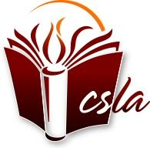Member of Church & Synagogue Library Association

Young Readers…
Mother and Daughter Visit Weekly
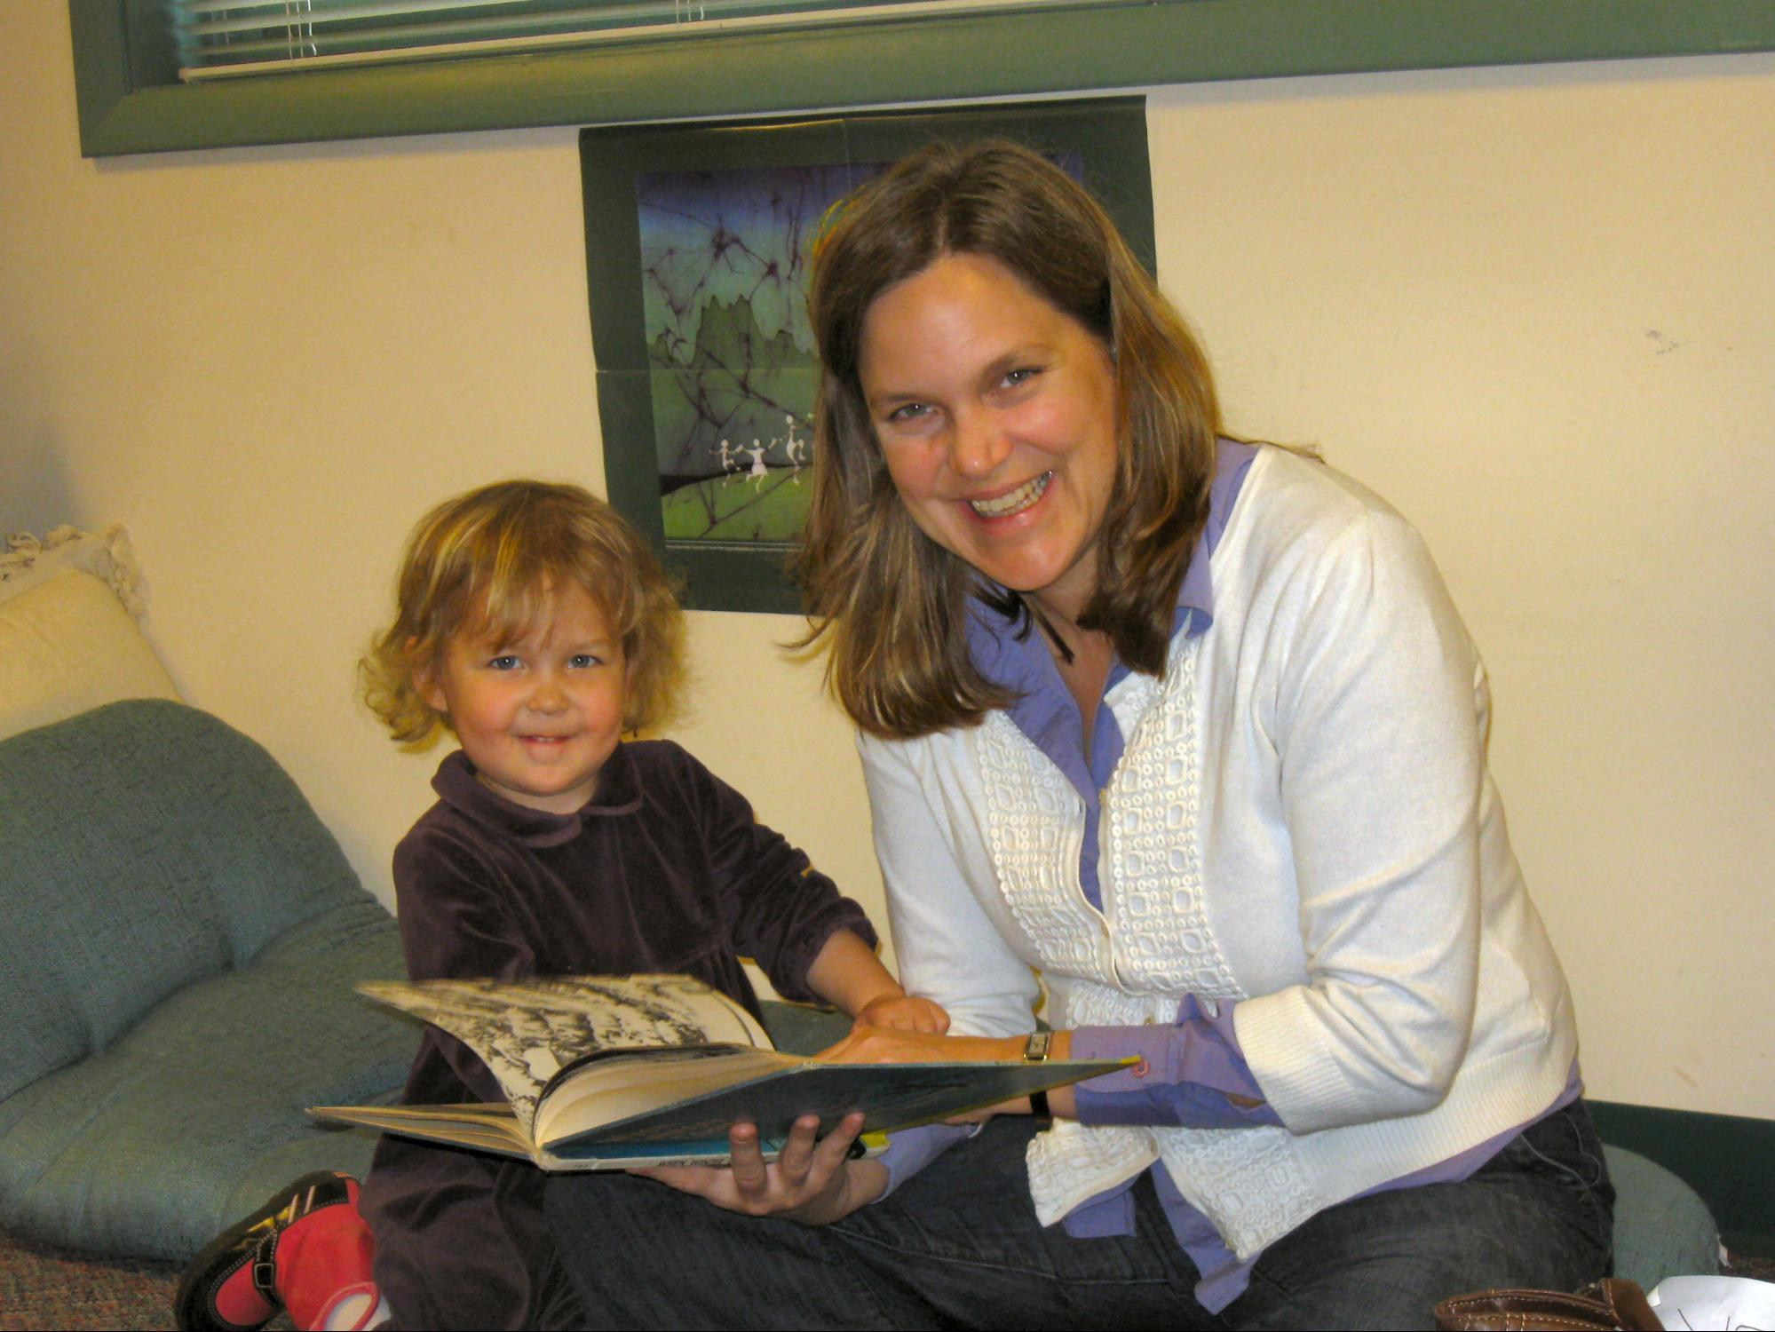
We discovered the church library last summer during the summer children’s reading program, when Sela had just turned two. Since then, we have read in the library almost every Sunday after church. Sela’s favorite part of coming to church is choosing new books, reading in the library, and then checking them out herself. (Although she has also just discovered the joy of “getting some hugs” in the sanctuary!) As a busy parent, it is so convenient to get books at church rather than making a separate trip to the public library. Thanks to the library committee and volunteers for all that you do! Jennie Knight

Summer Storytelling & Children’s Reading Program Begins June 6, 2010
Will Swinson is organizing the Sunday morning storytelling sessions for children in the library beginning June 6, 2010. Angela Riccetti and the library committee are planning to kick off the children’s summer reading program on the same day. Stay tuned for more information about these events.
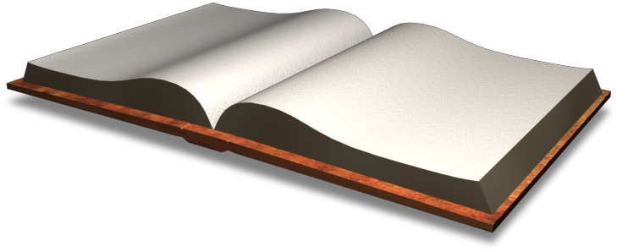
Evolution vs. Faith
A new book has been added to the library shelves entitled The Language of God by Francis S. Collins (Dewey class #215). Dr. Collins is a physician-geneticist who headed the Human Genome Project and was appointed to head the National Institutes of Health by President Obama. He says his book has the evangelical community as its primary audience “…because I think that’s where the greatest stir is going on.” Newsweek magazine said this is “an effort by Christian believers to confront the so-called new atheism on its own intellectual turf, without benefit of scripture or revelation.” Dr. Collins also edits a website called Biologos.org. This is a site designed to help answer the questions of serious believers who trust in science but want to drill deeper in the light of faith. Check it out.
Library Mission
The committee recently completed a policy and procedure manual which is available for review on the library desk and on our webpage. In it we state our mission is to provide a collection of materials for members and friends which will
- Serve those who seek to grow in their understanding of the Christian faith
- Serve those seeking to develop a deeper understanding of one’s self and one’s role in the community and the world
- Provide for the support of the church’s programs and covenant
Circulation Policy
The Library is open whenever the building is open. Self service check out procedures are posted on the library desk. A library committee member is usually available for assistance for about fifteen minutes after Sunday worship service.
All materials may be checked out for a two-week period. Materials may be renewed. There is no limit to the number of items a patron may check out. Returned materials should be placed in the basket on the desk marked “return books here”. There are no overdue fines. However, we would appreciate your returning overdue materials before checking out more.
We also have copies of worship service DVD’s available for check out.

Photo by Jan Murphy

Continued on Page 2

Continued from Page 1

MY TREASURED BOOKS
by Jim Holmes
Books that influenced my life:
1. Walden by Henry David Thoreau. The book also included his famous essay on Civil Disobedience. Thoreau challenged me to step back from society and take a new look at things.

2. The Memory of Old Jack by Wendell Berry. I particularly remember the episode in the book where the main character talks with an Amish farmer --Isaac Troyer asking him about buying his neighbors land to be more successful. Isaac Troyer replies that it would be more work, plus he'd lose his neighbor.

3. Lame Deer, Seeker of Visions by John (Fire) Lame Deer. Lame Deer's Native American insights on American society are effective critiques on money and success. I particularly remember his chapter entitled "The green frog's skin" referring to his description of the dollar bill.

4. Ecology of a Cracker Childhood by Janisse Ray. I loved her imagery and one beautiful chapter entitled "Forest Beloved" where she compares pine forests to cathedrals.

A book to which I always return: Zen and the Art of Motorcycle Maintenance by Robert Pirsig. His discussion of quality and values is one of the best I've ever read. I especially liked the section on getting stuck and the opportunity to seek creative solutions.

Classic that I really tried to read but could never finish: Cold Mountain by Charles Frazier.

Book that I am reading right now: The Hemingses of Monticello by Annette Gordon-Reed. The history of the famous slave family owned by Thomas Jefferson and his relationship with Sally Heming.

Book that I recommend for your children: A Wrinkle in Time by Madeleine L'Engle. A beautiful story of the power of love. [Check it out of the church library.]

Look for more “TREASURED BOOK” series from other Oakhurst members in future newsletters.

Your Library Committee (we’re here to help):
Harold Hoffman, co-chair - Halbea2000@bellsouth.net
Jan Murphy, co-chair – jamnga@bellsouth.net
Rachael Beascoechea – robeas138@bellsouth.net
Carolyn Copenhaver - CdenC@aol.com
Al Crisp - ACCrisp@aol.com
Lou Clymore – leonluella@bellsouth.net
Angela Riccetti - AJRICCETTI@Comcast.net

