Library Newsletter

Oakhurst Baptist Church, Decatur, GA www.oakhurstbaptist.org Issue #8, Spring 2011

Donated Books:
“We Love ‘Em”
By Harold Hoffman
Nine out of ten books we shelve are donated by members and friends of Oakhurst Baptist Church. This has been the case for the past decade or more. There are two methods for donating books or DVD’s:
1. You may wish to give a new book in memory or in honor of someone or in celebration of an anniversary or event. We prefer to purchase hard backed books and the average cost of a book or DVD these days is about $25 to $30 per item. We are able to shop for best buys. We will soon have an updated comprehensive list of books we would like to purchase available in the library or you can pick a book from our Wish List 2008 posted on our webpage. This method keeps our collection more balanced on subjects, keeping in mind that we are a church library (see our mission statement on the church library’s webpage.)
2. The second method of giving is to donate books and DVD’s which you own. Please put your name on a note with the donated materials. If you are going to donate more than a dozen items, please contact Harold Hoffman in advance. At the present time, he chooses which non-fiction items go into our collection and which are passed on to others. Carolyn Copenhaver does the same work for our fiction section. We would like more recent titles on practical Christian education, ministry, young adult, teen and upper elementary age fiction and biography, plus DVD’s with a moral point or intent. ☺

Membership Cards

We would like each family who has one or more members who check out library materials to fill out a membership card, listing all family member names. This is particularly important for families with children who use the library so that we can identify the adult family member or guardian to contact when a checked out item is past due. Please fill out a card located on the desk in the library. ☻
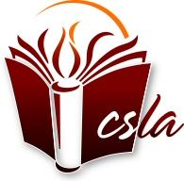Member of Church & Synagogue Library Association

National Library Week April 10-16 “Create your own story @ your library”
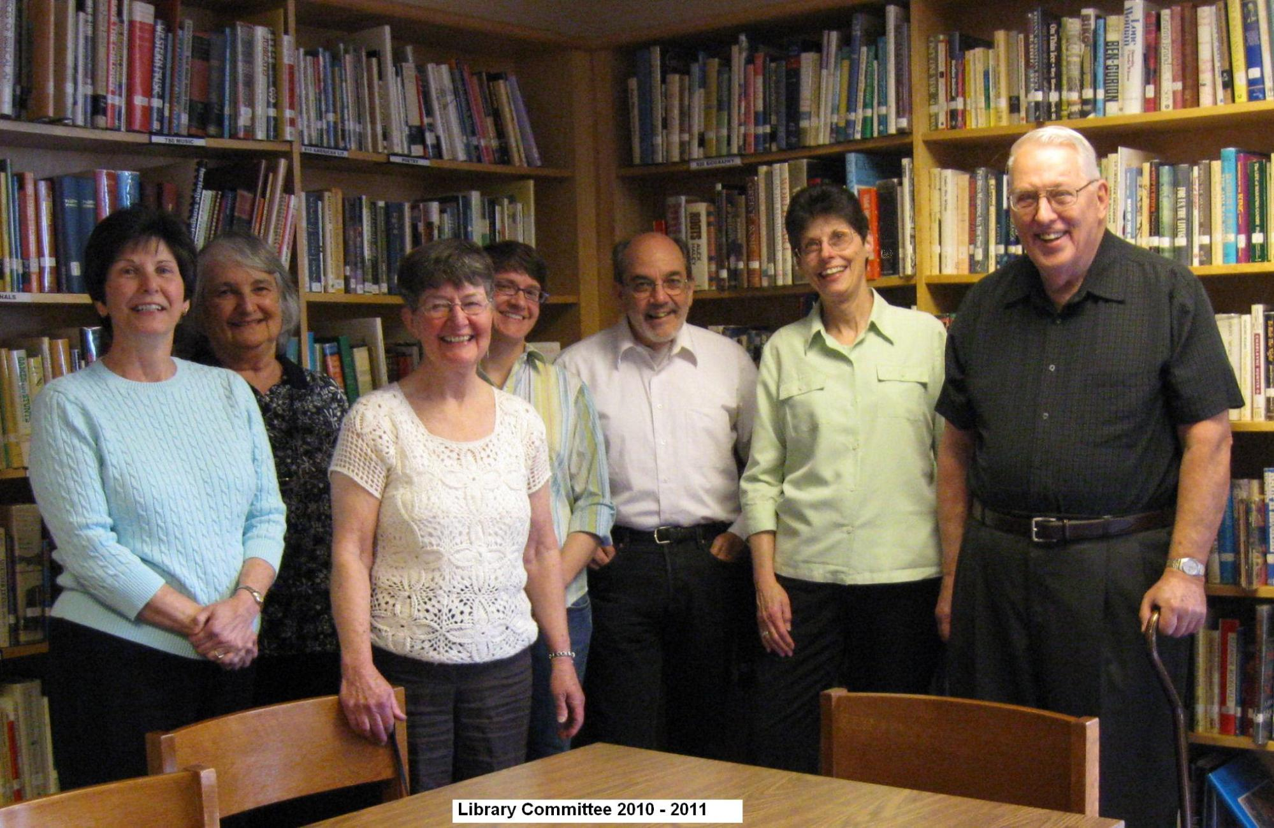
Library Committee Members, from Left to Right: Rachael Beascoechea is in charge of automation and inputting the collection on the computer. Carolyn Copenhaver is our fiction specialist, providing numerous donations of current fiction books, writing reviews and screening donated fiction books. Lou Clymore & Angela Riccetti plan and facilitate the children’s summer reading program and follow-up on overdue books. Al Crisp is in charge of circulation and re-shelving returned books. Jan Murphy (co-chair) handles administrative duties and newsletter preparation. Harold Hoffman (co-chair) is in charge of non-fiction, screening donated books, purchasing new additions to fill out our collection, and weeding outdated materials.
We have a few other ad-hoc volunteers who help us out on special projects, for which we are so grateful. Thanks to each committee volunteer and other helpers who work diligently to make your library a place of comfort, inspiration, meditation, entertainment and information. Most of all, thanks to all Oakhurst members and friends who use the library and media resource center—you make our work worthwhile. ☺
“Brain Books” Special Collection
“Brain Books,” a special collection on loan from Carolyn Copenhaver, is now installed in the library. Her collection features 17 books about the brain, including five books on the Dana Foundation’s list of “The Great Brain Books, Revisited.” (www.dana.org) According to its website, “The Dana Foundation is a private philanthropic organization that supports brain research through grants and educates the public about the successes and potential of brain research.”
These books were collected by our Library Committee member, Carolyn Copenhaver, over the past 5 years. Oakhurst readers may check out these books with no due dates and no late fees. Carolyn requests that borrowers sign her books in and out according to instructions at the collection site. She has prepared a notebook with handouts, book lists, and book reviews to assist you with your reading.
The collection includes the Dana.org members’ most popular choice, The Brain That Changes Itself (2007), by Norman Doidge, one of the first neuroscience books for laypersons “exploring the plasticity of the brain—something that was only recently proven to exist.” Other books in the collection explain the latest findings on glial cells, long mistakenly thought to be “just glue that holds the brain together,” (The Other Brain by R. Douglas Fields, 2010); the neuroscience of reading (Reading in the Brain, by Stanislas Dehaene, 2009); the neuroscience of decision-making, (How We Decide, by Jonah Lehrer, 2010); the neuroscience of music (This Is Your Brain on Music by Daniel J. Levitan, 2006), and an astonishing spiritual memoir by a brain-injured Harvard brain scientist (My Stroke of Insight by Jill Bolte Taylor, 2009.)☺
Useful Website Resources
Baptists Today resource page for staff, youth, seniors, community mission teams
http://www.biblical-art.com/ for library staff, Sunday School teachers & library patrons
http://www.biblegateway.com/ for all
http://classic.net.bible.org/home.php for Sunday School teachers, ministerial staff & library patrons
http://www.librarything.com/ for all readers
http://www.bartleby.com/ “literature, reference, and verse…[for] students, researchers, and the intellectually curious.”
http://librarybooklists.org/ for all who love to read

Continued on Page 2

MY TREASURED BOOKS
by Mary Jo Crawford
Books that influenced my life:
1. To Kill a Mockingbird by Harper Lee: What’s not to like? A riveting plot, memorable characters with real depth to them, a setting searingly portrayed, and a female child narrator and point of view. It is a masterpiece in every sense of the word, and probably the most important factor in my aspiration to write.
2. Dark Night of the Soul by Thomas Moore: When one is floundering in a morass of depression, every area of life is involved---personal relationships, career obligations, time management, energy levels, and on and on. One is or feels totally alone, abandoned or deprived even, of all contact, comfort, and solace. Even God, the Creator and Sustainer of life, is missing or seems to be. Thomas Moore understood all this; he had been there. This book was instrumental in my recovery from such a period in my life.
3. Proclaim Jubilee by Maria Harris: This book not only helped me to grasp fully the biblical concept of jubilee, but also helped me to apply it to my own life in a practical fashion upon turning 50 years of age.
4. All Nancy Drew Mysteries by Carolyn Keene (who also wrote the Hardy Boy Mysteries). First, this series of books contributed greatly to my becoming a compulsive reader. I inhaled them because the intelligent, gutsy girl that solved mysteries and everyone admired and respected her fascinated me. Her father, like my own, believed in her and trusted her judgment even as he worried as any father would occasionally. In addition, they were the first books that were all mine and only mine. That’s a big deal when you have four siblings!
5. Hiroshima by John Hersey. This book started me down the road of thinking critically about issues surrounding conflict and peace, and the costs associated with each.
Book to which I always return:
Pride and Prejudice by Jane Austen: This is the book where I fell in love with social satire as an art form. This is probably my favorite novel; I could not tell you how many times I have read this book!
Book I reread that I enjoyed as much or even better: Other than Pride and Prejudice, I enjoyed rereading Prince of Tides by Pat Conroy. There is a passage in that novel that is so achingly beautiful that it takes my breath away. In fact, there are several such passages.
Book I reread that disappointed me: The Moonstone by Willkie Collins. This is the first mystery novel written in English, which impressed me greatly the first time around, but not so much years later when I reread it.
Classic that I really tried to read but could never finish: A Confederacy of Dunces by John Kennedy Toole and The Lord of the Rings by J. R. R. Tolkien are just two examples of fantasy/sci fi fiction that I cannot suspend belief long enough to buy into them.
Book that I am reading right now: This I Believe: The Personal Philosophies of Remarkable Men and Women edited by Jay Allison, Dan Gediman, and John Gregory.
Book that I recommend for your children: The Story of Ferdinand by Munro Leaf. This is a book for everyone who wants an excuse to slow the world down a bit and feel good about it, not guilty. This book encourages taking time to enjoy nature and contemplation---good things to share with your children.

Look for more “TREASURED BOOK” series from other Oakhurst members in future newsletters.

Your Library Committee (we’re here to help):
Harold Hoffman, co-chair - Halbea2000@bellsouth.net
Jan Murphy, co-chair – jamnga@bellsouth.net
Rachael Beascoechea – robeas138@bellsouth.net
Carolyn Copenhaver - CdenC@aol.com
Al Crisp - ACCrisp@aol.com
Lou Clymore – leonluella@bellsouth.net
Angela Riccetti - AJRICCETTI@Comcast.net

