Library Newsletter

Oakhurst Baptist Church, Decatur, GA www.oakhurstbaptist.org Issue #10, Spring 2012

Online Catalog Is Here !
We are so excited to announce that our online library catalog is now available. You can search for a book or DVD in our collection using our online search engine from any computer by title, author, or subject. The link to the online catalog is:
http://catalog.ourlibraryonline.com/start.php?a=OAKHSTGA
No password is required. Please give it a try, save it in your favorites and let us know how you like it. If you can’t remember the URL, just go to the library page under “Oakhurst as Family” on the OakhurstBaptist.org website and find the link in the 3rd paragraph. Of course, you can still search for books by browsing the shelves or using the printed catalog in notebooks kept on top of the old outdated card catalog cabinets. ♦
New Non-fiction Books
Four recently published books--we consider anything published within the past decade to be recent--have been added to the collection.
Biblical Archaeology: A Very Short Introduction by Eric H. Cline (NY Oxford University Press, 2009) Call No. 220.93 CLI
Making Judgments Without Being Judgmental: Nurturing a Clear Mind and a Generous Heart by Terry D. Cooper (IVP Books, 2006) Call No. 241 COO
Divine Embrace, The: Recovering the Passionate Spiritual Life by Robert E. Webber (Baker Books, 2006) Call No. 248 WEB
Why God Won't Go Away: Is the New Atheism Running on Empty? by Alister McGrath (Thomas Nelson, 2011) Call No. 239.7 MCG

“A truly great library contains something in it to offend everyone.” ~Jo Godwin

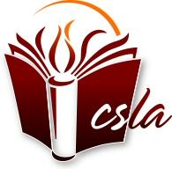Member of Church & Synagogue Library Association

Featured Book Displays
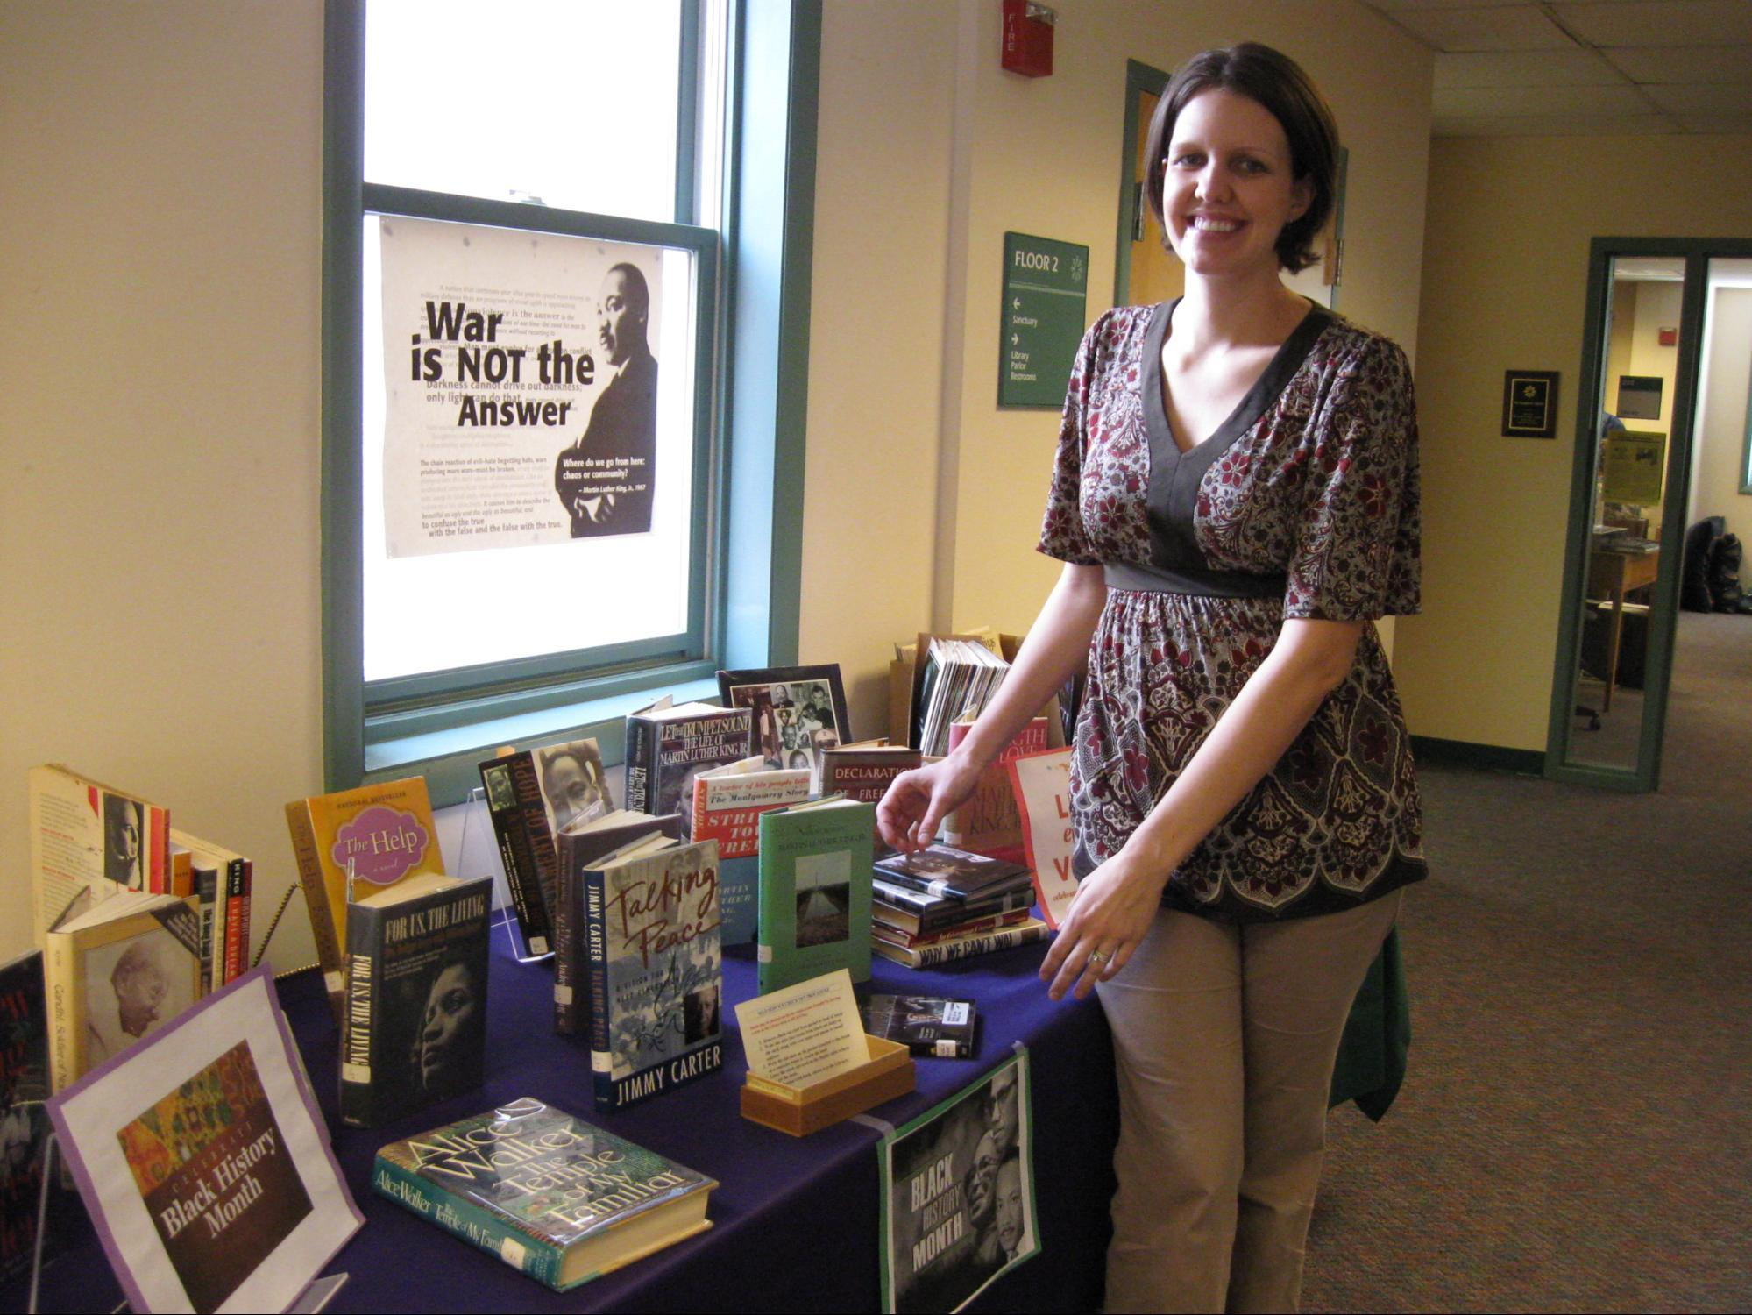Brittany Mackey poses beside one of many beautiful displays she designed of books featured during seasonal events. Harold Hoffman selected books from our library that were relevant during the Advent season, and to commemorate the 400-year anniversary of the KJV Bible as well as these pictured in celebration of Martin Luther King, Jr. during February. We thank Brittany for her creative displays. ☺
Library Supports Covenant

In January 2012, the Covenant Committee, through Tolly Williamson, invited the library staff to make resources available in support of our Covenant. We are happy to provide these materials for check-out and study since the library’s mission policy states that we are to “provide for the support of the church’s programs and Covenant.” Each month a selection of library materials that are relevant to the featured covenant intention are displayed in the library. The library committee members who have selected or will select the displayed materials each month include Harold Hoffman (February), Carolyn Copenhaver (March), Lou Clymore (April), Jan Murphy (May & August), John Starbuck (June), and Rachael Beascoechea (July). Please come by and check out our offerings.☺

Oakhurst Writer’s Corner

Two exciting new additions to the Writer’s Corner:

Lynn Farmer's collection of 18 poems, The Rare, Persistent Light, has won the Georgia Poetry Society's Charles Dickson Chapbook Contest. Every two years this award honors poetic achievement in a chapbook-length work. Lynn read from her collection at the award presentation in Dahlonega on April 21, 2012. Dr. B.J. Robinson, contest judge, commented that "The collection as a whole offers substance-in-words that staves off voids of loss, grief, and death, giving us recovery with loss, and no easy answers." The prize includes the publication of a limited edition of chapbooks which will be for sale. The book’s cover also includes one of Lynn’s photographs. A book signing will be arranged by the library committee for church members very soon, so stay tuned for details.

Amy Greene, a former long time member, now ministering at the Cleveland Clinic in Ohio has donated a bound copy of her Doctor of Ministry thesis titled Critical Components in the Formation of Clinical Pastoral Education Supervisors. If you are a counselor of any type, there is something here for you. She first tells her own story of her decades- long learning experiences which includes the influence Oakhurst Baptist Church has had on her personal and professional life.

Passages Exhibit

The Church and Synagogue Library Association (CSLA), Metro Atlanta Chapter, of which we are a member, sponsored a trip in February to the traveling exhibit called Passages : Experience the Bible Like Never Before. Jan, Rachael and Harold went with the group to the exhibit in Dunwoody and returned giving it very high marks. It was a truly remarkable experience to see dozens of ancient Bibles and artifacts so beautifully displayed. But it is not a static experience…at every turn as you walk through there are talking mannequins (ala Disney), 3D shadow boxes and short films. We highly recommend the exhibit particularly for those interested in the history of the Bible. If you go, be sure to rent the MP3 headphones for a fuller experience. The exhibit has been extended through June 30, 2012. For information about hours, location, and pricing, go to www.explorepassages.com.

MY TREASURED BOOKS
by Jennifer Hornbuckle
A Tale Of Two Cities by Charles Dickens. We read it in my 9th grade English class, and whether it was the teacher, Mrs. Newland, who guided us through it so well, or just the book itself, I do not know. It's the one that opened my eyes to the beauty of literature.

The Autobiography of Malcolm X by Alex Haley. I had the opportunity to do a "term paper" in 11th grade on Malcolm X, and took it, because this book had been on my parent's bookshelf for many years, and I did not know who he was. It changed my life in reading about a man whose life was vastly different from my own in many ways, yet I found commonality with his struggle for identity and acceptance as a 17-year-old.

A Separate Peace by John Knowles. I have loved this book about young men struggling with growing up, facing the oncoming war and the struggles of life since I was in high school. A few years ago, I sent a copy of this book, along with The Autobiography of Malcolm X and Night by Elie Wiesel to my nephew, Andrew, when he graduated from college.

The Diary Of Anne Frank. When I read the play in 6th grade, it moved me beyond words. It still does. When my niece, Ashley, turned 10, I sent her a copy of a new edition of the book, which she told me she really enjoyed.

Cry, The Beloved Country by Alan Paton. I read this for the first time a couple of years ago, after it had been on my bookshelf for several years. What a powerful story about love, truth and reconciliation.

A Prayer For Owen Meany by John Irving. Owen Meany touched my heart like few characters ever have. His courage, his convictions, his belief in himself are a lesson for us all. The movie that was "suggested" by this, Simon Birch, is nothing like the book. If you haven't already, read the book!

Father Melancholy's Daughter + Evensong by Gail Godwin. Godwin writes as if she lived this herself. I identified with the main character, a female who eventually became a minister, and faces heartache and embraces hope in her struggle to care for herself and for others.

New and Selected Poems by Mary Oliver. Her poetry illuminates the holy spirit, nature and so many facets of life.

Poems to Live By In Uncertain Times ed. by Joan Murray. This volume includes a vast array of poets, it’s little in size and big in inspiration.

Your Library Committee (we’re here to help):
Harold Hoffman, co-chair - Halbea2000@bellsouth.net
Jan Murphy, co-chair – jamnga@bellsouth.net
Rachael Beascoechea – robeas138@bellsouth.net
Carolyn Copenhaver - CdenC@aol.com
Al Crisp - ACCrisp@aol.com
Lou Clymore – leonluella@bellsouth.net
John Starbuck - kcubratsej@aol.com

